70

HomeWork 4 David Browning

70.00

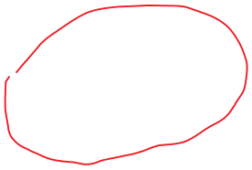

Tuesday, February 23, 2016

7:48 AM

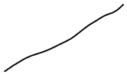

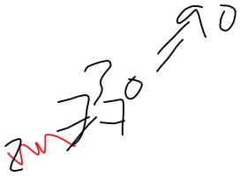

-90,

20.40

o •

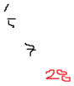

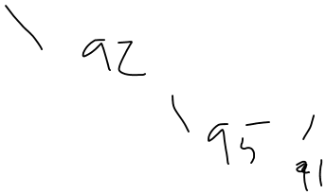

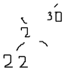

-50

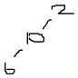

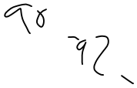

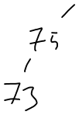

C:\F45216A5\043B3167-F90D-48B7-880E-9656B4F8CBD4_files\image010.png

1. Figure 1 is an avl tree. Figure 2 is not an avl tree.
2. .
   1. Insert(28)
   2. Insert(55)
3. .
   1. remove(30)
   2. remove(20)

Figure 6 is not an AVL tree. 80 remains

unbalanced. As such I may not be able

to answer the question as accurately.

I will do my best.

As it stands, before removing 20, 80 is the

lowest unbalanced node. We have a RR case.

We must do a Left rotation. 85 becomes the next lowest

unbalanced node. It is a left right case so a left-right double

rotation should solve it. Unfortunately, when 77 takes its

place, its right node, 78 is now the lowest unbalanced node

it is a right right case, and a left rotation solves it.

The tree is now balanced, and can be considered an AVL Tree.

balancing took 4 rotations to balance. It is at this point we

may remove 20. When we do this, 30 becomes the

lowest unbalanced node. A left rotation of 30, leaves 35

unbalanced, and a right rotation of 35 leaves the entire tree

balanced with a height of 4, and after looking back at the work I've

done I now realize I've left out 80...the very node that causes the figure to be unbalanced in the first place. Unfortunately for me, it's late, and I've yet to begin on the coding section of the assignment.

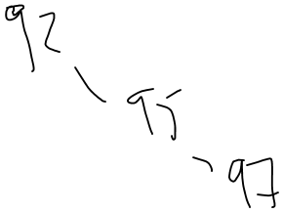

/

9)

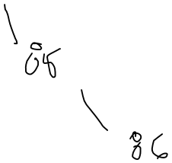

I

760

To

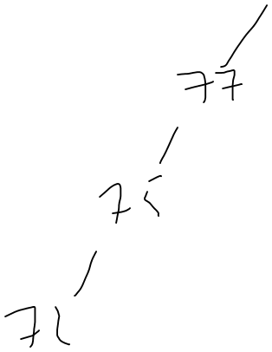

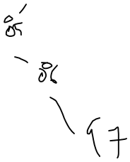

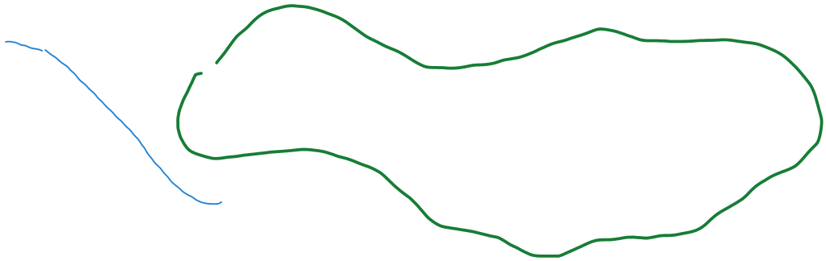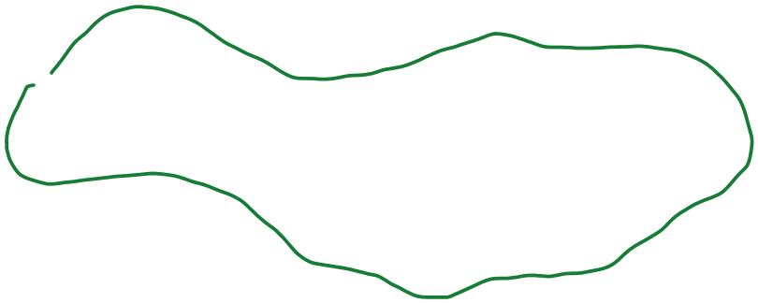C:\F45216A5\043B3167-F90D-48B7-880E-9656B4F8CBD4_files\image017.png

.40

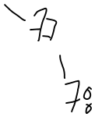

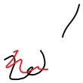

1859;

'4

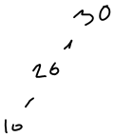

C:\F45216A5\043B3167-F90D-48B7-880E-9656B4F8CBD4_files\image021.png

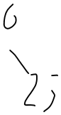

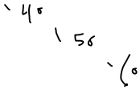

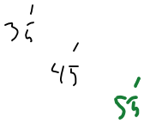

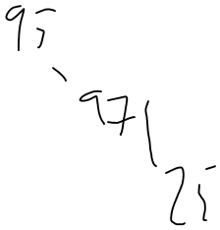

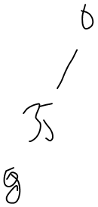

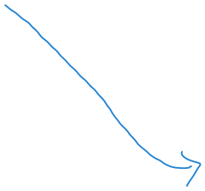

40¢

30s;

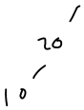

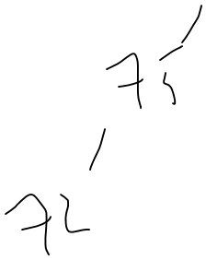

☹

is

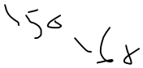

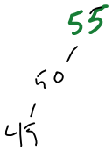

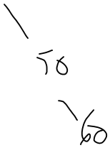

-60

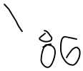

¥

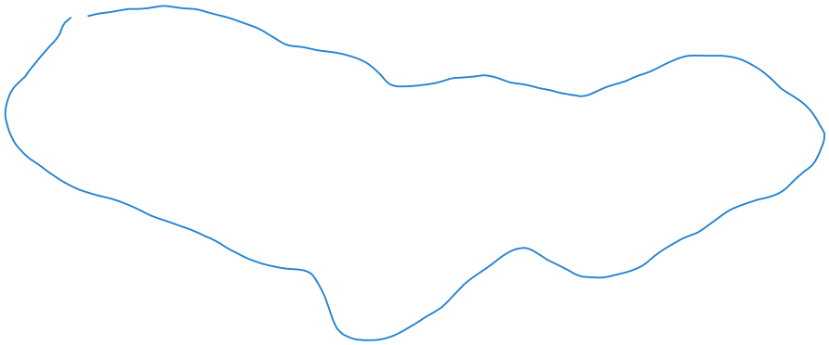

30

i!

•40

: 3:

•. '40

in'

it

in;

[5

yi

it

19 t

•-40:

-46

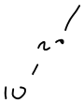

¥

ion. ini:

-40

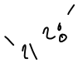

of

on

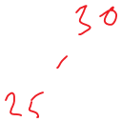

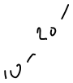

- "

'46

so

/ 186

'78

'50

77

Yo

77,

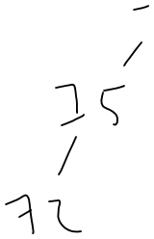

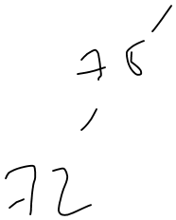

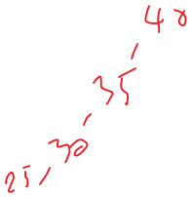

88

'yo

78'

-60

-86,

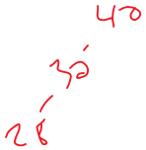

'to

'60

'yr